**Actors. User Stories.**

This artefact contains the specification of all actors that interact with the system and their respective *user* *stories* as an agile documentation of the project requirements. This section pretends to illustrate the communication between actors (with *case diagrams*) and describe the potential interactions from users with the system – *user stories*.

**1. Actors**

An actor is a person, organization, or external system that plays a role in one or more interactions with a system. Actors may inherit from another actors and are never part of the system that is being modeled (Ambler, 2004). An action performed by an actor implies a response from the system. For **CityFix** system let’s consider the following actors represented in Figure 1 (Annex 1) and described in Table 1.

Table 1 - Actors Description

|  |  |  |
| --- | --- | --- |
| Identifier | Description | Example |
| User | Generic user; may access to public information (tickets, entities contacts, problems solved, etc.) | n/a |
| Visitor | Unauthenticated user; may register or log into the system. | n/a |
| Authenticated | Authenticated user; may logout from the system, edit his profile or recover his password. | joesteves |
| Poster | Authenticated user; may upload, vote and associate an entity to a ticket. | tmiranda |
| Moderator | Authenticated user; responsible for ticketing management (validate its content, share information with the competent entity that’s going to solve the problem, assign extra points to users based on the points system, etc.) | cris92 |
| Entity | Authenticated user; responsible for retrieving information from the applied tickets and updating the current tickets’ state. | cmp |
| Administrator | Authenticated user; responsible for users management, system security and data integrity. | admin |
| Google API | External API which will be used to detect the user’s geographical localization. | gmaps |

**2. User Stories**

An user story is a high-level definition of a requirement, containing all the enough information to make it possible to produce a reasonable estimate of the effort to implement it (Ambler, 2004). The description of a potential interaction from an user with the system focuses the behaviour requirements, rather than design aspects. Usually, an user story is described by the following template (Cohn, 2004):

*As a (role) I want (something) so that (benefit).*

For **CityFix** system, let’s consider the following *user* *stories* described on the tables below, based on the above template.

**2.1 User**

Table 2 – User

|  |  |  |  |
| --- | --- | --- | --- |
| Identifier | Name | Priority | Description |
| US001 | Search | High | As an User I want to search all public information (user and entity profiles, etc.) so that I can know who I should contact if there is a problem near my location. |
| US002 | View Ticket | High | As an User I want to view a ticket’s content so that I can know if there is a problem near my location and what actually happened. |

**2.2 Visitor**

Table 3 - Visitor

|  |  |  |  |
| --- | --- | --- | --- |
| Identifier | Name | Priority | Description |
| US101 | Login | High | As a Visitor I want to login into the system so that I can have access to restricted information. |
| US102 | Register | High | As a Visitor I want to register myself so that I can upload new tickets. |
| US103 | Password Recovery | High | As a Visitor I want to recover my authentication credentials so that I can access the platform if I forget my password or username. |

**2.3 Authenticated**

Table 4 - Authenticated

|  |  |  |  |
| --- | --- | --- | --- |
| Identifier | Name | Priority | Description |
| US201 | Logout | High | As an Authenticated I want to be able to logout from the system so that I can terminate my session correctly. |
| US202 | Profile | High | As an Authenticated I want to edit my profile so that I can change my basic information and authentication credentials. |
| US203 | Password Recovery | High | As a Visitor I want to recover my authentication credentials so that I can access the platform if I forget my password or username. |

**2.4 Poster**

Table 5 - Poster

|  |  |  |  |
| --- | --- | --- | --- |
| Identifier | Name | Priority | Description |
| US301 | Add Ticket | High | As a Poster I want to submit a ticket to the system so that I can show that there’s a problem near my location. |
| US302 | Edit Ticket | High | As a Poster I want to edit a ticket in the system so that I can update its information. |
| US303 | Remove Ticket | High | As a Poster I want to remove a ticket so that I can hide its content from the public. |
| US304 | Associate Ticket | High | As a Poster I want to associate a ticket to an entity so that it helps to solve a problem. |
| US305 | Manual Location | High | As a Poster I want to manually add a location so that I can add a ticket after a situation when I didn’t have internet connection. |
| US306 | Automatic Location | High | As a Poster I want the system to automatically detect my location so that I don’t have to add it manually. |
| US307 | Vote | High | As a Poster I want to vote on a ticket so that I can contribute to the truthfulness of that ticket and its respective user. |
| US308 | Access Tickets | High | As a Poster I want to access to problems on my location so that I know what’s happening near me. |
| US309 | List Tickets | High | As a Poster I want to have access to a list of my submitted tickets so that I can keep track of their status. |
| US3010 | Associate Image to Ticket | High | As a Poster I want to associate an image to a ticket so that an user or entity can easily detect what’s happening on that location. |

**2.5 Moderator**

Table 6 - Moderator

|  |  |  |  |
| --- | --- | --- | --- |
| Identifier | Name | Priority | Description |
| US401 | Validate Tickets | High | As a Moderator I want to validate tickets so that an entity can solve the problem. |

**2.6 Entity**

Table 7 - Entity

|  |  |  |  |
| --- | --- | --- | --- |
| Identifier | Name | Priority | Description |
| US501 | Edit Information | High | As an Entity I want to edit my information so that I can provide the latest data to the active users. |
| US502 | Change Ticket State | High | As an Entity I want to change a ticket’s state so that an active user may know the current state of that specific problem. |

**2.7 Administrator**

Table 8 - Administrator

|  |  |  |  |
| --- | --- | --- | --- |
| Identifier | Name | Priority | Description |
| US601 | Manage Users | High | As an Administrator I want to manage users so that I can delete or mute an user if necessary. |
| US602 | Manage Content | High | As an Administrator I want to manage the system’s content so that whenever a change is necessary, there is permission to do so. |
| US602 | Daily Statistics | Low | As an Administrator I want to get daily statistics about the website’s visits so that I can know the time when the server is busier. |

**3. User Interfaces**

The user interface design process goal is to produce a user interface which makes it easy (self explanatory), efficient and enjoyable (user friendly) to operate in the way which produces the desired result.

**4. Architecture**

# **Bibliography**

Ambler, S. (2004). *The Object Primer* (3rd Edition). Cambridge: Cambridge University Press.

Cohn, M. (2004). *User Stories Applied: For Agile Software Development* (3rd Edition). Chicago: Addison-Wesley Professional.

Raymond, E. S., & Landley, R. W. (2004). *The Art of Unix Usability.* Pearson Education, Inc.

**Annexes**

**Annex 1**

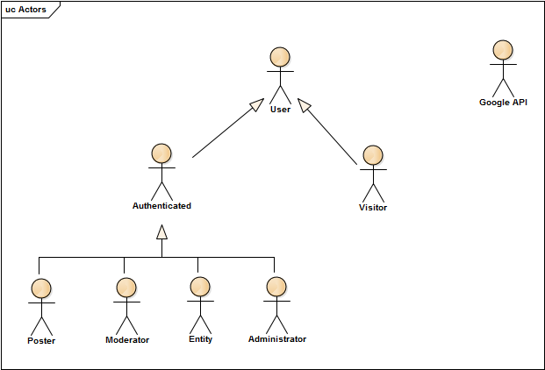

Figure 1 - Actors